**Task Description #1:**

• Introduce a buggy Python function that calculates the factorial of a number using recursion. Use Copilot or Cursor AI to detect and fix the logical or syntax errors.

**Expected Outcome #1:**

**•**Copilot or Cursor AI correctly identifies missing base condition or incorrect recursive call and suggests a functional factorial implementation.

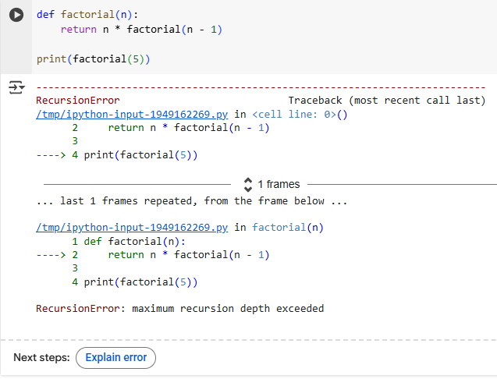

Prompt:   
Please explain this error:   
RecursionError: maximum recursion depth exceeded

The error is a RecursionError because the recursive function factorial is missing a base case. It will keep calling itself indefinitely until the maximum recursion depth is exceeded. To fix this, we need to add a base case to stop the recursion when n is 0 or 1.

Corrected Code:

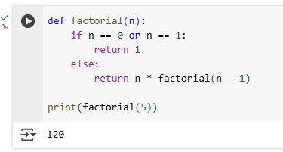

**Task Description #2:**

**•**Provide a list sorting function that fails due to a type error (e.g., sorting list with mixed integers and strings). Prompt AI to detect the issue and fix the code for consistent sorting**.**

**Expected Outcome #2:**

**•**AI detects the type inconsistency and either filters or converts list elements, ensuring successful sorting without a crash

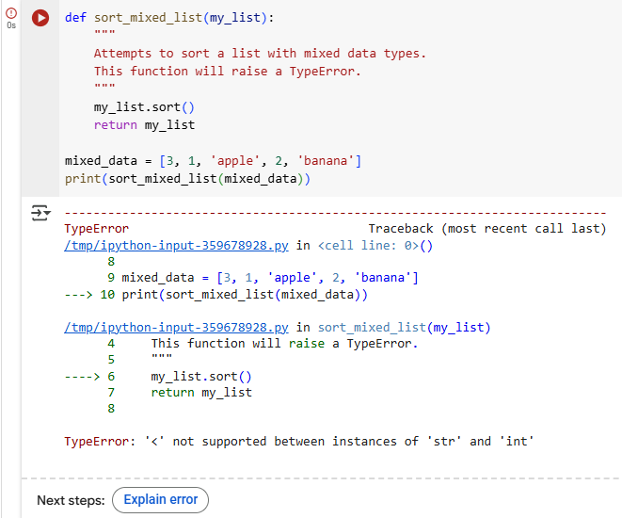

The code above will fail with a TypeError: '<' not supported between instances of 'str' and 'int'. This error occurs because Python's default sorting algorithm tries to compare each element with others in the list to determine their relative order. It does not know how to evaluate a comparison like 2 < 'apple', leading to a crash.

Correct Code:

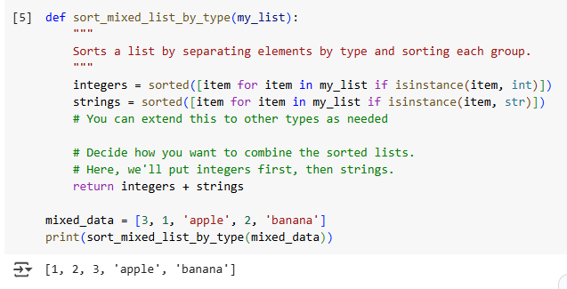

**Task Description #3:**

**•** Write a Python snippet for file handling that opens a file but forgets to close it. Ask Copilot or Cursor AI to improve it using the best practice (e.g., with open() block).

**Expected Outcome #3:**

**•** AI refactors the code to use a context manager, preventing resource leakage and runtime warnings

PROMPT:   
generate python code file handling that opens a file but forgets to close it

The error in the selected code is an UnsupportedOperation: not readable. This error occurs because you opened the file in write mode ("w"), which only allows writing. After writing "This is some text.", the file pointer is at the end of the file, and the file object is not in a state to be read from. To read from the file after writing, you need to either close the file and reopen it in read mode ("r") or a mode that allows both reading and writing ("w+", "r+", "a+").

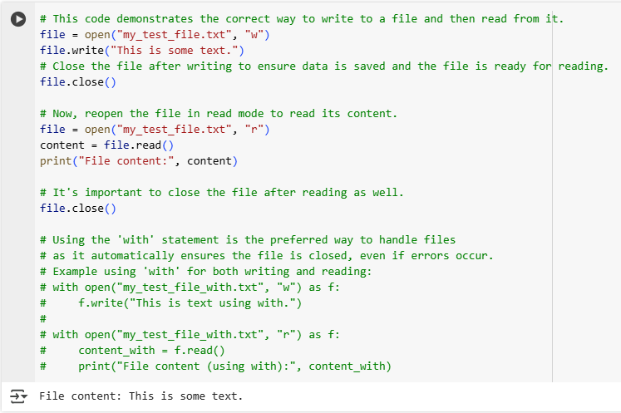

**Task Description #4:**

**•** Provide a piece of code with a ZeroDivisionError inside a loop. Ask AI to add error handling using try-except and continue execution safely.

**Expected Outcome #4:**

**•** Copilot adds a try-except block around the risky operation, preventing crashes and printing a meaningful error message.

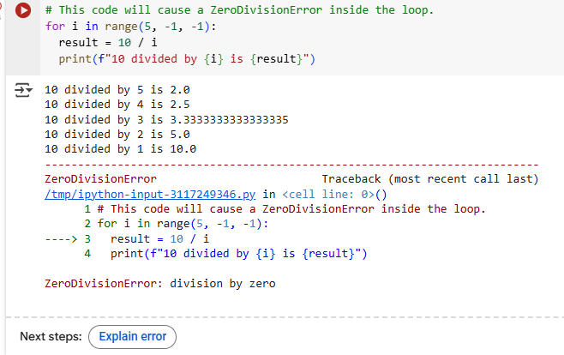

The error in the selected code is a ZeroDivisionError. This happens when the loop variable i becomes 0 during the last iteration (range(5, -1, -1) includes 0), and you attempt to perform the division 10 / i. Division by zero is mathematically undefined and raises this error in Python.

To fix this, you can use a try-except block to catch the ZeroDivisionError when it occurs and handle it gracefully. Here's the modified code that uses a try-except block:

I've fixed the code to handle the ZeroDivisionError using a try-except block, and it now runs without crashing.

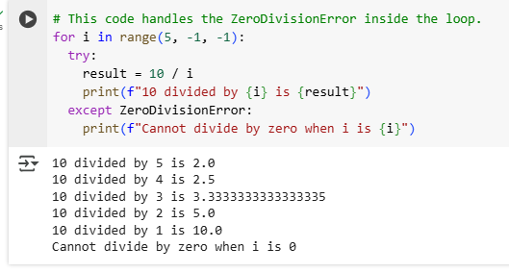

**Task Description #5:**

**•** Include a buggy class definition with incorrect __init__ parameters or attribute references. Ask AI to analyze and correct the constructor and attribute usage.

**Expected Outcome #5:**

**•** Copilot identifies mismatched parameters or missing self references and rewrites the class with accurate initialization and usage.

Prompt: generate a class with incorrect __init__ parameters or attribute references

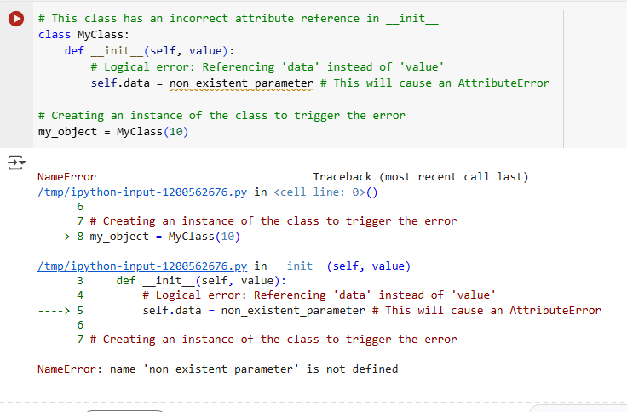

The error in the selected code is a NameError: name 'non_existent_parameter' is not defined. This means that when Python tried to execute the line self.data = non_existent_parameter inside the __init__ method, it couldn't find a variable or name called non_existent_parameter in the current scope.

Correct code:

